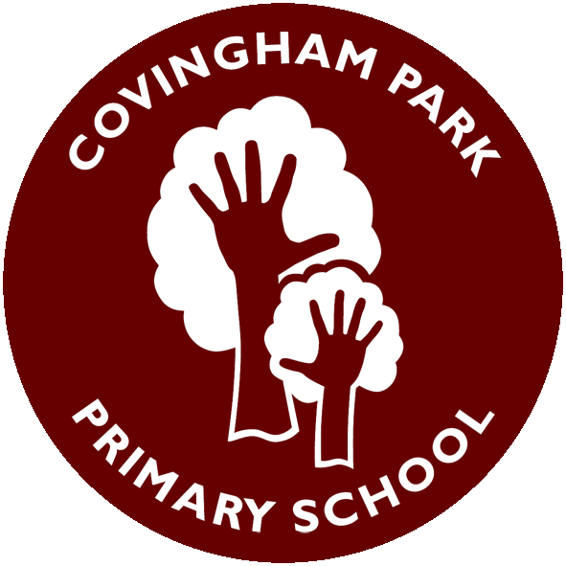
Curious. Inspired. Resilient
Science Progression of Vocabulary
 |  | Year 1 | Year 2 | Year 3 | Year 4 | Year 5 | Year 6
Biology | Plants | Key Vocabulary:  leaf, flower, blossom, petal, fruit, berry, root, seed, stem, trunk, branch, bark, stalk, bud, deciduous, evergreen, wild, garden, light, shade, warm, cool, healthy, growth, bulb, seedling |  | Key Vocabulary:  roots, stem, trunk, leaf, flower, pollen, dispersal, germination
Biology | Animals Incl. Humans | Key Vocabulary:  fish, amphibian, reptile, bird, mammal, carnivore, herbivore, omnivore, offspring, adult, life cycle, hygiene |  | Key Vocabulary:  nutrition, nutrients, carbohydrates, proteins, fats, vitamins, minerals, fibre, skeleton, muscle, joint, rib, skull, spine | Key Vocabulary:  digestive system, mouth, esophagus, stomach, small intestine, large intestine, incisor, canine, molar, producer, predator, prey | Key Vocabulary:  foetus, adolescence, puberty, hormones, adulthood, data, comparison | Key Vocabulary:  heart, lungs, pulse, nutrients, lifestyle, drugs, alcohol
Biology | Living Things and their Habitats |  | Key Vocabulary:  living, dead, never been alive, habitat, micro-habitat, shelter, food, food chain, predator, prey |  | Key Vocabulary:  classification, environment, habitat, impact, migrate, hibernate | Key Vocabulary:  life cycle, metamorphosis, reproduction, sexual, asexual, pollination, fertilisation, runner, bulb, cutting | Key Vocabulary:  vertebrate, invertebrate, micro-organism, bacteria, fungus, classification, characteristics, Linnaeus
Biology | Evolution and Inheritance |  |  |  |  |  | Key Vocabulary:  inheritance, variation, adaptation, natural selection, evolution, fossil
Chemistry | Materials | Key Vocabulary:  material, object, property, hard, soft, rough, smooth, waterproof, absorbent, shiny, dull, metal, plastic, fabric, glass, wood, rock | Key Vocabulary:  material, property, flexible, stretchy, stiff, rigid, waterproof, absorbent, transparent, opaque, metal, plastic, fabric, glass, wood | Key Vocabulary:  igneous, sedimentary, metamorphic, fossil, erosion, mineral | Key Vocabulary:  solid, liquid, gas, state change, melting, freezing, evaporation, condensation, water cycle, °C | Key Vocabulary:  conductor, insulator, reversible, irreversible, dissolve, filtration, evaporation, solubility
Physics | Understand movement, forces and magnets |  |  | Key Vocabulary:  force, push, pull, friction, magnet, magnetic, attract, repel, pole, north, south |  | Key Vocabulary:  force, gravity, air resistance, water resistance, friction, balanced forces, unbalanced forces, streamlined
Physics | Understand Light and Sound |  |  | Key Vocabulary:  light source, dark, reflection, mirror, opaque, transparent, translucent, shadow, sun safety | Key Vocabulary:  vibration, pitch, volume, insulation, medium, distance |  | Key Vocabulary:  light ray, straight line, reflection, refraction (intro), image, shadow, periscope
Physics | Understand Electricity |  |  |  | Key Vocabulary:  circuit, cell, battery, wire, bulb, switch, buzzer, motor, conductor, insulator |  | Key Vocabulary:  cell, battery, voltage, series circuit, component, switch, bulb, buzzer, motor, symbol
Physics | Understand the Earth’s Movement in Space | Cycle B - Seasonal change |  |  |  | Key Vocabulary:  solar system, planet, star, orbit, rotate, axis, day, night, time zones, spherical

