
Covingham Park Primary School

Relational Policy

Date Written: July 2026
Author: James Wood
Next Review Date: July 2027

Contents
1. Introduction
2. Aims and Intent
3. P.A.C.E Principles – Overcoming Blocked Trust
4. Blocked Care – Recognising and De-escalating
5. Communication Guidelines
6. Links to Other Policies
7. Review

1. Introduction
This policy details the agreed and codified approach all adults working in the school must take when developing positive relationships with pupils in the school. We believe that relationships are the bedrock of productive learning behaviour and that consistency of approach from all school stakeholders is vital to maintaining an environment where children feel safe, secure and supported.
This policy document should be viewed in conjunction with the school's specific policy on behaviour, which can be found on the policies section of the Covingham Park Primary School website.
2. Aims and Intent
"You can be strict without being nasty, maintain boundaries without cruelty and correct children without aggression." (Paul Dix, Pivotal Education)
"A child who pushes you away is a child who needs connection before anything else." (Kelly Bartlett, Encouraging Words for Kids)
"Deep down in every child, however invisible, hostile or rejecting they may seem is a deep longing to be seen, known and truly understood." (L. Bomber, Inside I'm Hurting)
Covingham Park Primary School is committed to creating an environment where positive behaviour is not merely ordered, but explicitly taught. It is at the heart of productive learning and the responsibility of everyone to maintain the highest standards of personal conduct.
Our relational policy aims to guide staff to teach self-discipline and reflection, not blind compliance. It echoes our core values with a heavy emphasis on collective kindness and understanding.
Our school values are 'Caring for pupils, Promoting Success' – this can be applied to a variety of situations and is taught and modelled explicitly. None more so than in our relationships with pupils. We work hard and are relentless in our expectation and consistency. We will not give up on children and we will not allow them to feel that our school isn't for them. Consistently 'showing up' and being emotionally available is the kindness we seek from all our staff.
We have an understanding that our demographic and catchment is broad and diverse. For a minority of pupils with pronounced social and emotional needs, following all of our high expectations for behaviour may be beyond their current developmental level. In these cases, children will have bespoke positive behaviour plans which mirror the school values and ethos.
Our aims will be achieved when:
- We create and maintain a school culture and climate which is consistent, safe and fosters connection.
- We recognise that being 'fair' is not about everyone getting the same (equality) but everyone getting what they need (equity) through appropriate support. There is no such thing as a 'one size fits all' policy.
- We live and breathe the mantra "connection before correction" and that 'consequences' aren't the first thought when someone hasn't met expectations.
- Pupils are provided with excellent role models who provide a secure base and the connection necessary to support connection (Emotionally Available Adults).
- We have a shared understanding that not all behaviours are a matter of 'choice'. We are careful with using the language of choice (e.g. 'good choice/bad choice') as it is not universally helpful.
- All staff are able to use PACE (Playful, Accepting, Curious, Empathetic) in interactions with children. We self-reflect on our own feelings and take steps to avoid blocked care (not being able to be emotionally available).
- We understand that consistency, predictability and security help to maintain boundaries for our pupils. Changing how we respond to behaviour does not mean we lose routines, expectations or structure. Nurture and structure can go hand in hand.
3. P.A.C.E Principles – Overcoming Blocked Trust
Children who have had a difficult start to life have often learned that the world is not a safe place and that people in it cannot be trusted to help them to stay safe. Without safety and security children cannot settle to learn and explore. Many also do not think that they deserve care and attention, and many feel deeply ashamed much of the time. These feelings and assumptions about the world underpin almost all the interactions they have with adults and their peers. Working with children who do not feel safe at school is demanding and asks a lot as a professional.
When we are faced with behaviour that is difficult, we will use Dan Hughes' PACE approach in order to connect with the child who may be struggling to regulate.
PACE refers to Playfulness, Acceptance, Curiosity and Empathy:
Playfulness
Playfulness involves spontaneity, openness and exploration. Being playful can defuse tense situations and is useful to manage minor behaviours as the pupil is less likely to respond with anger or defensiveness.
Acceptance
Acceptance involves unconditional positive regard for the pupil – we accept the pupil's inner experience without judgement and make sense of why the pupil is behaving in a certain way. Acceptance doesn't mean accepting the negative behaviours, but accepting the reasons behind the behaviour. When necessary, we criticise the behaviour itself, but not the pupil.
Curiosity
Curiosity involves wondering about the reasons behind the behaviours, rather than being angry. This shows the pupil that you care and helps them to make sense of their behaviour, feelings and experiences. Using phrases like, "I wonder if you are feeling like this because..." can open up discussions with pupils so we can connect before we correct.
Empathy
Empathy involves showing them that you understand how difficult they are finding things and reassuring them that you want to help manage this. We validate the pupil's emotional experience with phrases such as, "I can see how difficult that must have been for you," and we work together to find ways to support them.
4. Blocked Care – Recognising and De-escalating
Understanding how feelings direct actions. The work of neuropsychologist Stephen Porges helps us to understand what happens to us all when we perceive danger. His polyvagal theory suggests a hierarchy of three levels:
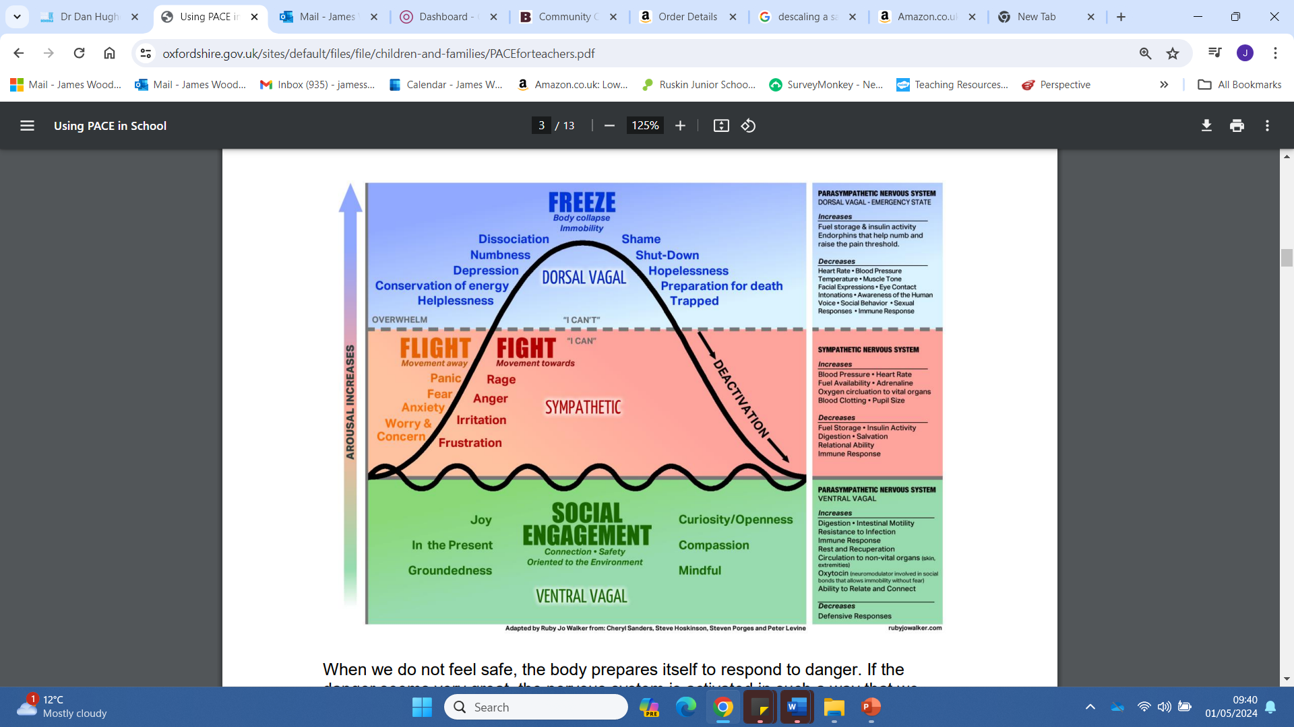
When people do not feel safe, the body prepares itself to respond to danger. If the danger seems very great, the nervous system is activated in such a way that we have a very high tolerance for pain, and often become very still. In this 'freeze' state, which is the state of greatest stress, children sometimes appear to 'zone out', show confusing behaviours such as laughing inappropriately as though they cannot stop, or even appear to fall asleep. Sometimes this is called "dissociation". When we perceive threat that is not at the highest level the body prepares itself for defence. Sometimes we call this "fight or flight". It is likely that you have seen this response on many occasions.
We know that children who have experienced trauma escalate into this state very quickly. It may look as though there was no trigger, or that the apparent trigger was very small. Many children who have experienced trauma are vulnerable to experiencing 'fight, fright or flight' reactions in everyday situations which would not normally make children feel afraid. This reaction is not conscious, is completely involuntary and out of their control. In order for children to be ready to learn, however, they need to be in the calm, open and engaged state described in the graphic above. Only in this state can they engage with adults and others to think about what has happened and how they can understand it together. When a child is challenging or threatening to adults, when they may feel deskilled or frustrated by the child, we know that our own defences are likely to kick in. At this point it is very difficult for adults to be in a calm, open and engaged state too. Many teachers are more likely at this point to revert to more traditional behaviour management styles which, unfortunately, do not work with children who have experienced trauma. Very often this is the point at which communication breaks down between adults and the child and the situation escalates. At this point it is vital that we recognise the signs of this in ourselves and step away to de-escalate the situation. We encourage all our staff to reflect on their own emotional state and to remember the principles of PACE when this occurs.
5. Communication Guidelines
Consistent communication from all staff is vital to ensure that children at Covingham Park Primary School feel safe and supported. The following guidelines are expectations for how all staff should communicate with pupils here.
- We keep language used the 'least obtrusive' and avoid unnecessary confrontation.
- We are assertive but never aggressive.
- Our tone is respectful and positive and we model this behaviour to the children.
- We are quick to re-establish relationships. We have high expectations, but we do not hold grudges.
- We separate the behaviour from the individual. We criticise negative behaviour and seek to understand it but we do not label the child themselves.
6. Links to Other Policies
This policy should be read alongside:
- the Behaviour Policy;
- the Anti-Bullying Policy;
- the SEND Policy;
- the Safeguarding and Child Protection Policy.
7. Review
This policy will be reviewed annually, or sooner if new evidence, changes to statutory guidance, or findings from monitoring indicate that revision is required.
Approved by: ______________________ Date: ______________
Next review: September 2026

