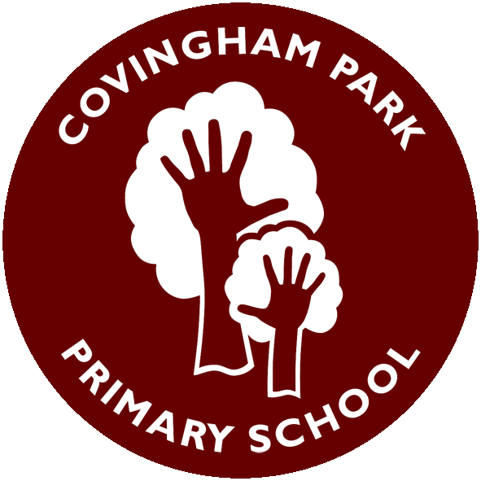
Curious. Inspired. Resilient
Year 6 Medium Term Plan (Term 1)
Subject | Week 1 | Week 2 | Week 3 | Week 4 | Week 5 | Week 6
Main Driver: Geography/History | Charles Dickens & Victorians | Charles Dickens & Victorians | Charles Dickens & Victorians | Charles Dickens & Victorians | Charles Dickens & Victorians | Charles Dickens & Victorians
Art/DT | Art: Portraits and Memories | Art: Drawing People and Expression | Art: Colour, Mood and Atmosphere | Art: Mixed Media Exploration | Art: Creating Final Artwork | Art: Final Outcome and Assessment- Identity and Change
Science | Hook- What makes it work? | Building Simple Series Circuits and representing these using symbols | How Does the Circuit Affect the Bulb? | How Does the Circuit Affect the Bulb? | Understanding the difference between renewable and non-renewable energy | Final Outcome and Assessment-Electricity Investigation
English - Writing | Narrative: A child discovers an object that transports them to different areas of childhood | Narrative: A child discovers an object that transports them to different areas of childhood | Narrative: A child discovers an object that transports them to different areas of childhood | Non-chronological report: A child’s life through the ages | Non-chronological report: A child’s life through the ages | Non-chronological report: A child’s life through the ages
English - Reading | Narrative- Original Dickens | Narrative- Street Child | Narrative- Lark rise to Candle ford | A non-chorological report based on electricity | A non-chorological report based on Charles Dickens | A non-chorological report based Victorian life
Maths | Number, Place Value and calculation | Number, Place Value and calculation | Number, Place Value and calculation | Number, Place Value and calculation | Area, Perimeter and Volume | Area, Perimeter and Volume
Computing | Computing – Communication and the internet | Computing – Communication and the internet | Computing – Communication and the internet | Computing – Communication and the internet | Computing – Communication and the internet | Computing – Communication and the internet
PSHE | Being me in my world- My year ahead | Being me in my world- Being a global citizen 1 | Being me in my world- Being a global citizen 2 | Being me in my world- The Learning Charter | Being me in my world-Our Learning Charter | Being me in my world- Owning our learning Charter
RWV | What do religions say when life gest hard? | What do religions say when life gest hard? | What do religions say when life gest hard? | What do religions say when life gest hard? | What do religions say when life gest hard? | What do religions say when life gest hard?
PE | Dance: the power of unity | Dance: the power of unity | Dance: the power of unity | Dance: the power of unity | Dance: the power of unity | Dance: the power of unity
Music | Songwriter | Songwriter | Songwriter | Songwriter | Songwriter | Songwriter
French | Phonics 1-3 school | Phonics 1-3 school | Phonics 1-3 school | Phonics 1-3 school | Phonics 1-3 school | Phonics 1-3 school

